MYSQL MOCKTEST
1. Retrieve Movie Details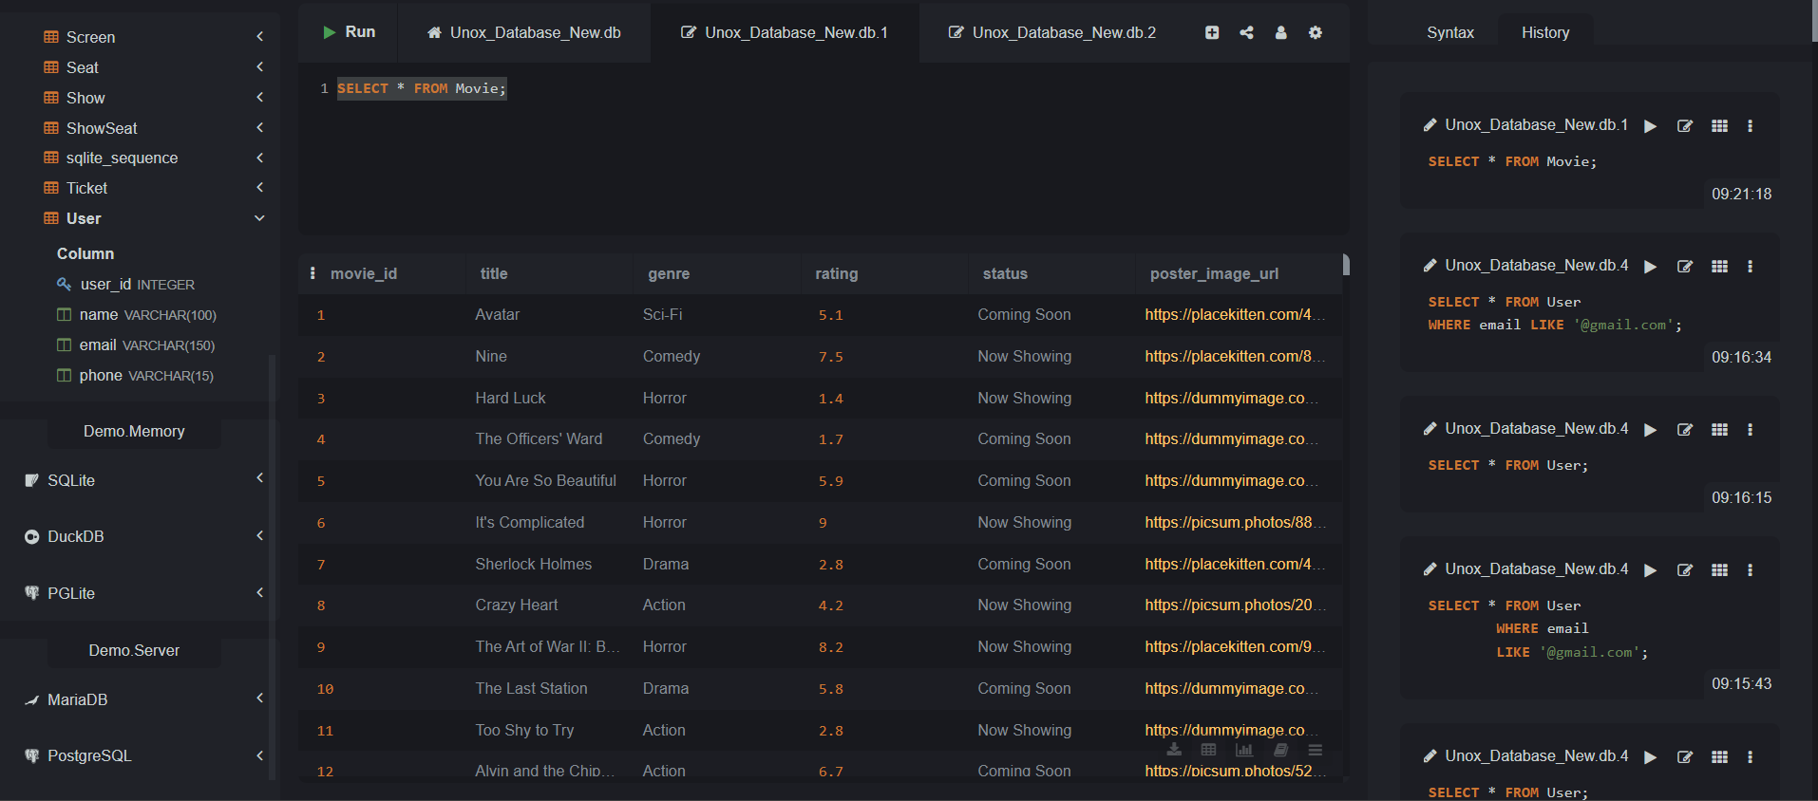
2. Display Screen Information with Aliases
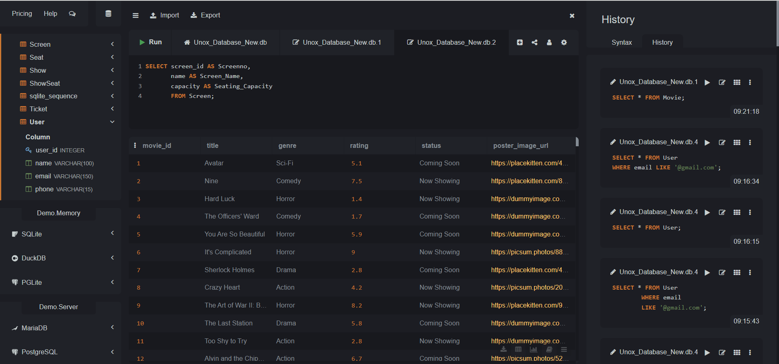
3. Filter Premium Screen Shows
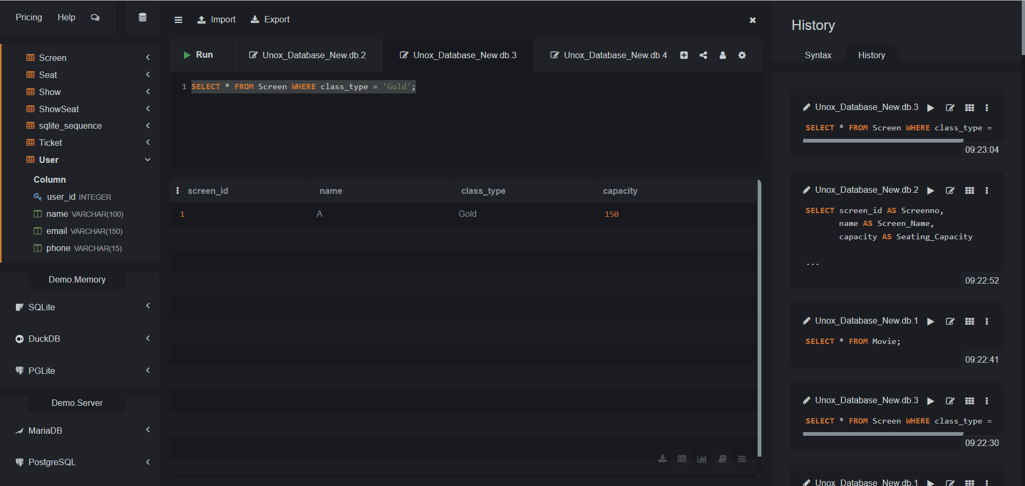
4. Identify Users by Email Domain
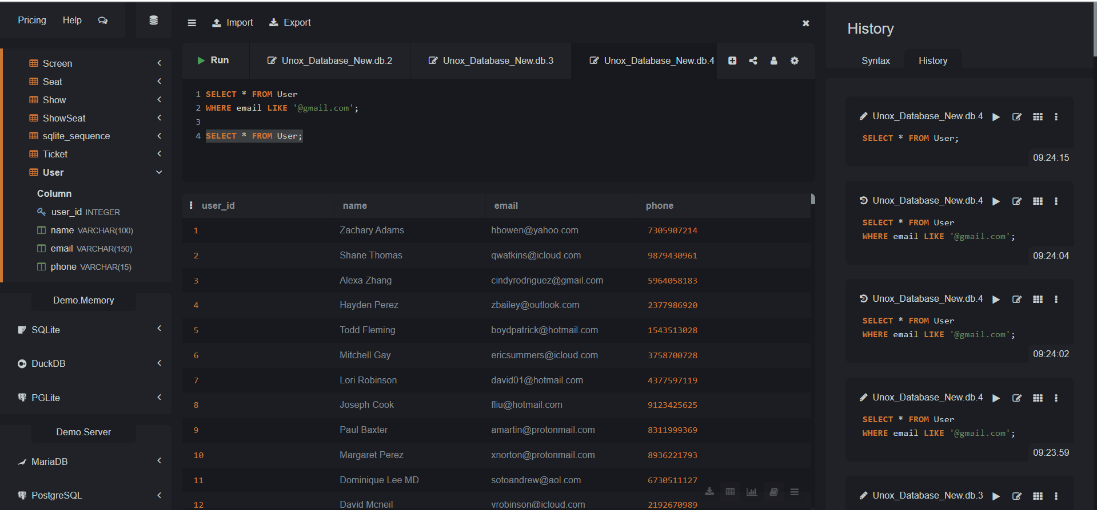
5. Find Upcoming Shows for a Specific Genre
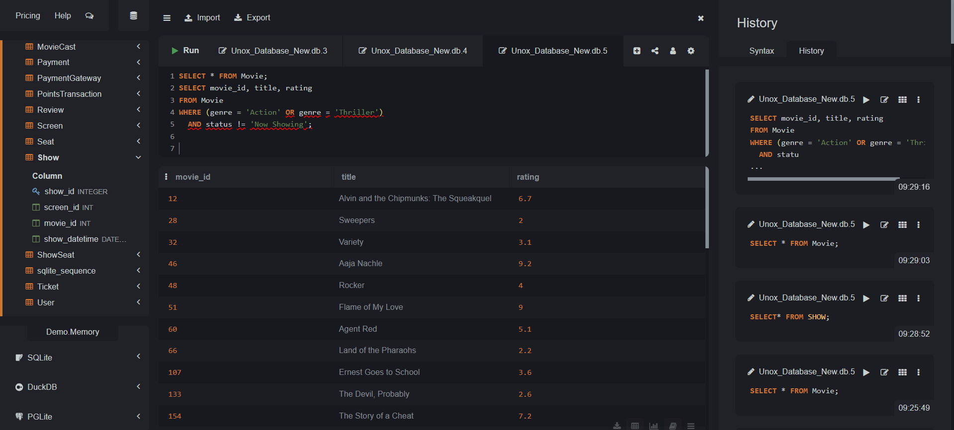
6. Shows Scheduled Within a Date Range
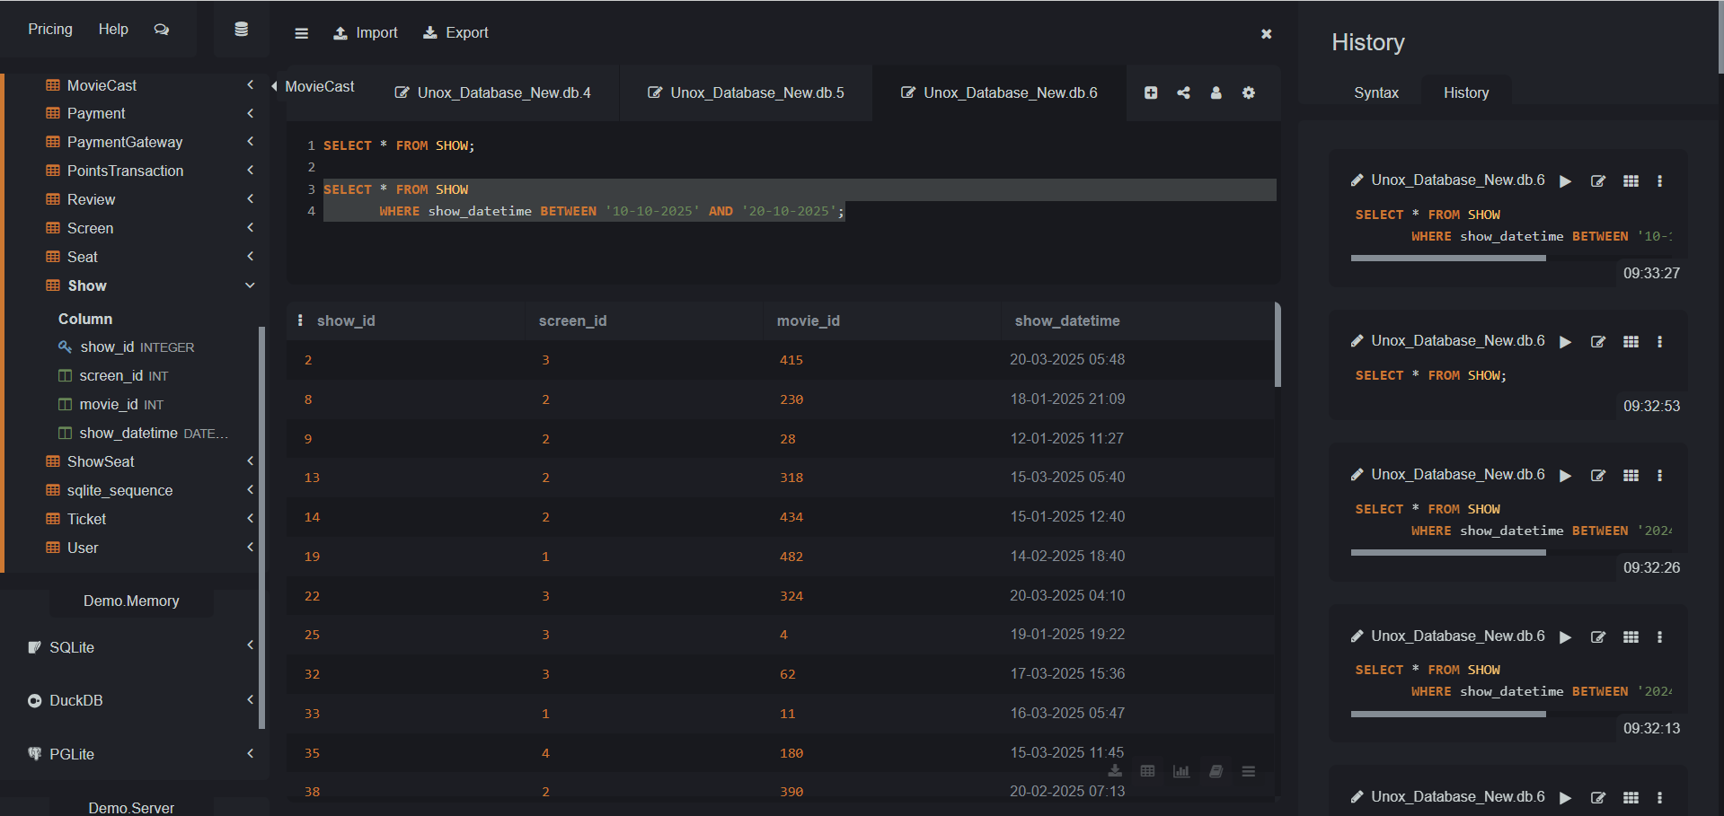
7. List Top Movies by Rating
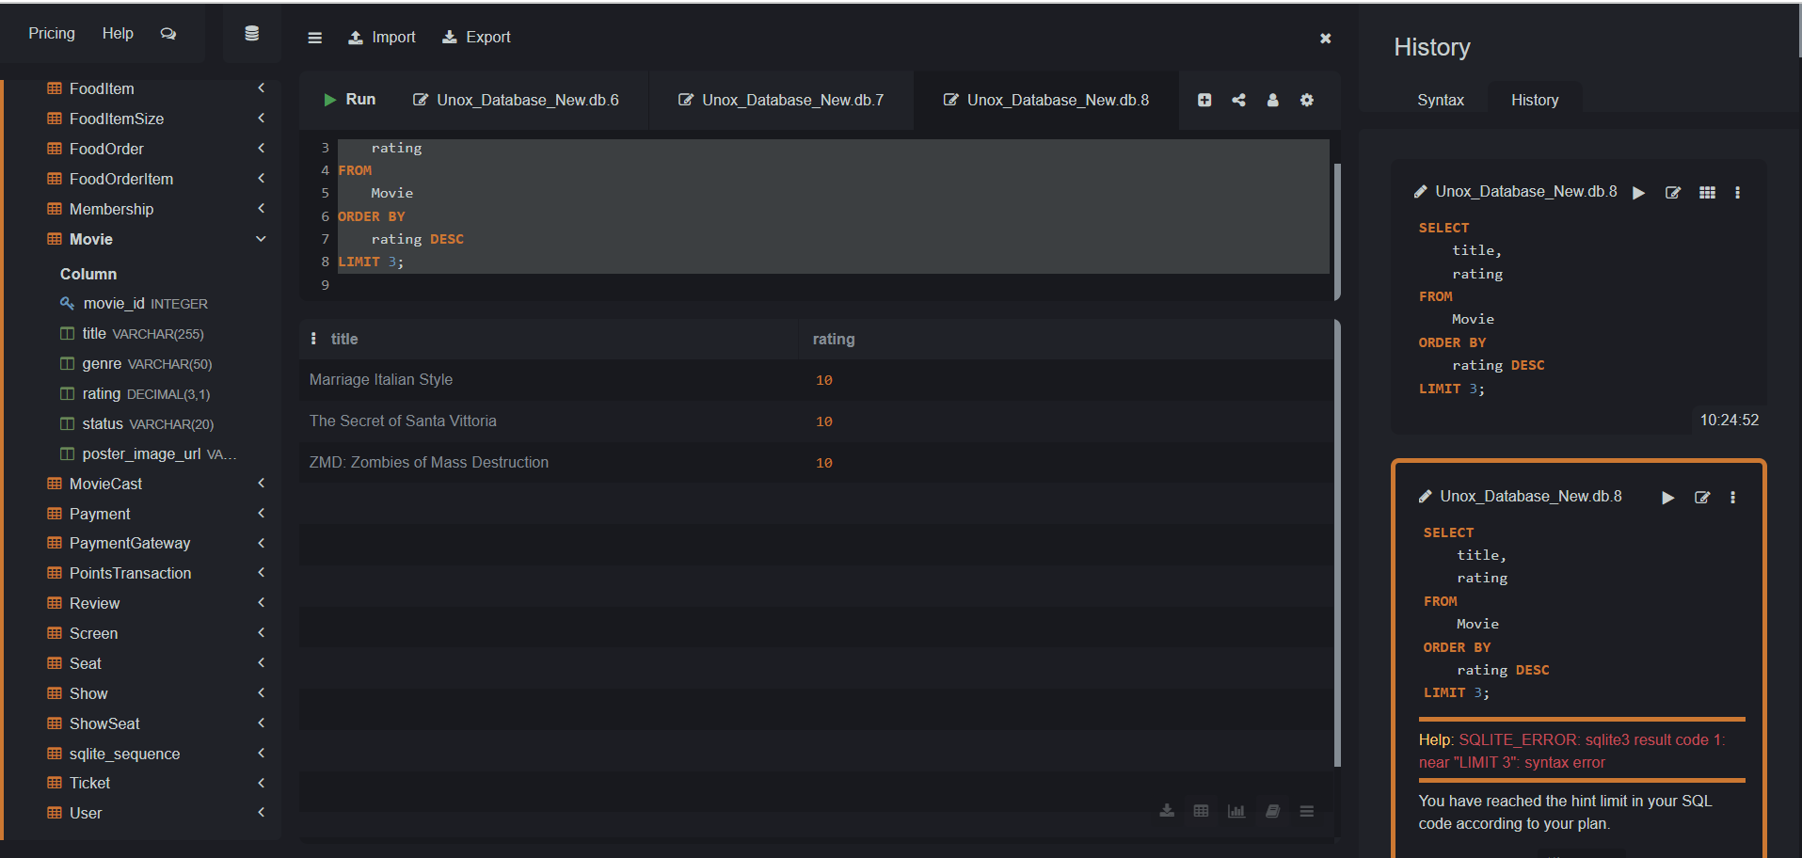
8. Count Bookings per Show
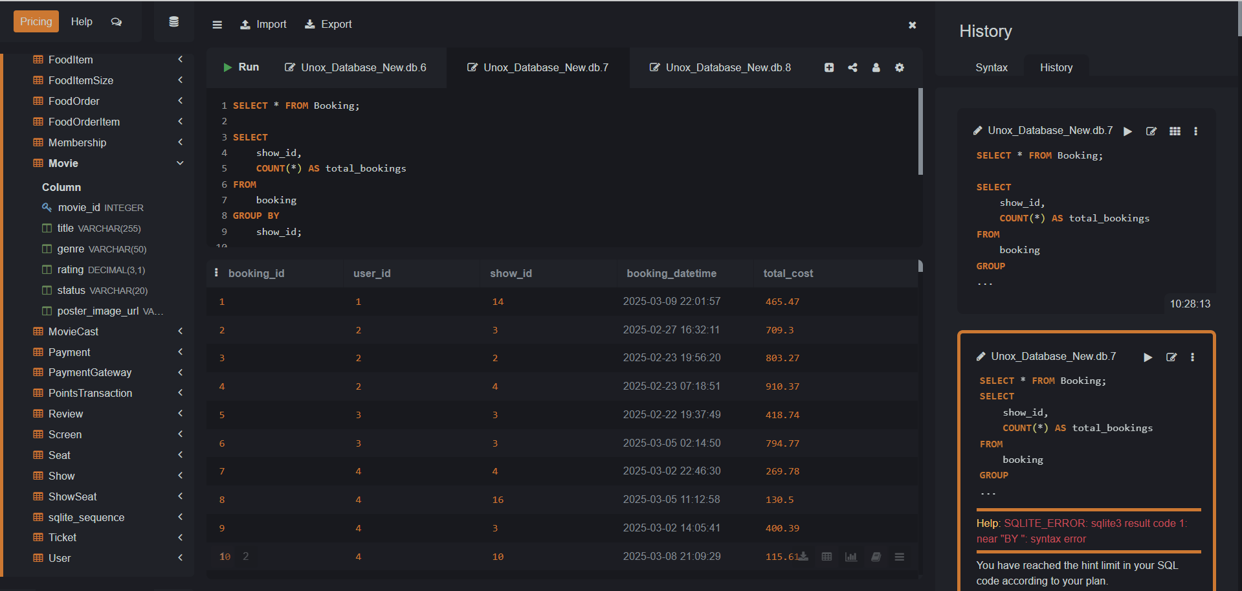
9. Find Unique Movie Genres
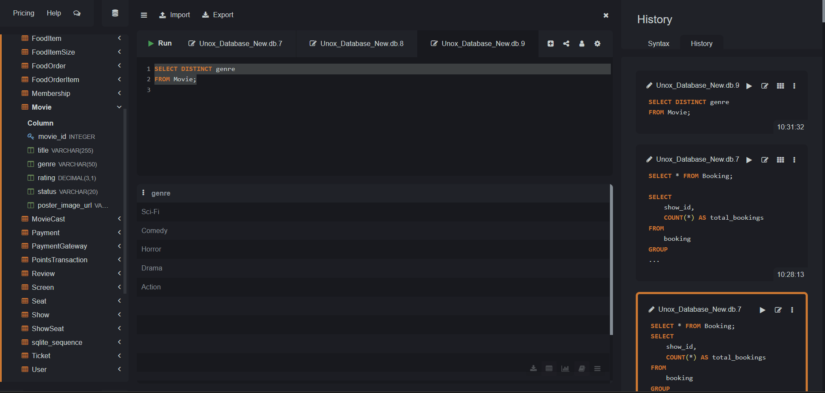
10. Display Recently Added Bookings
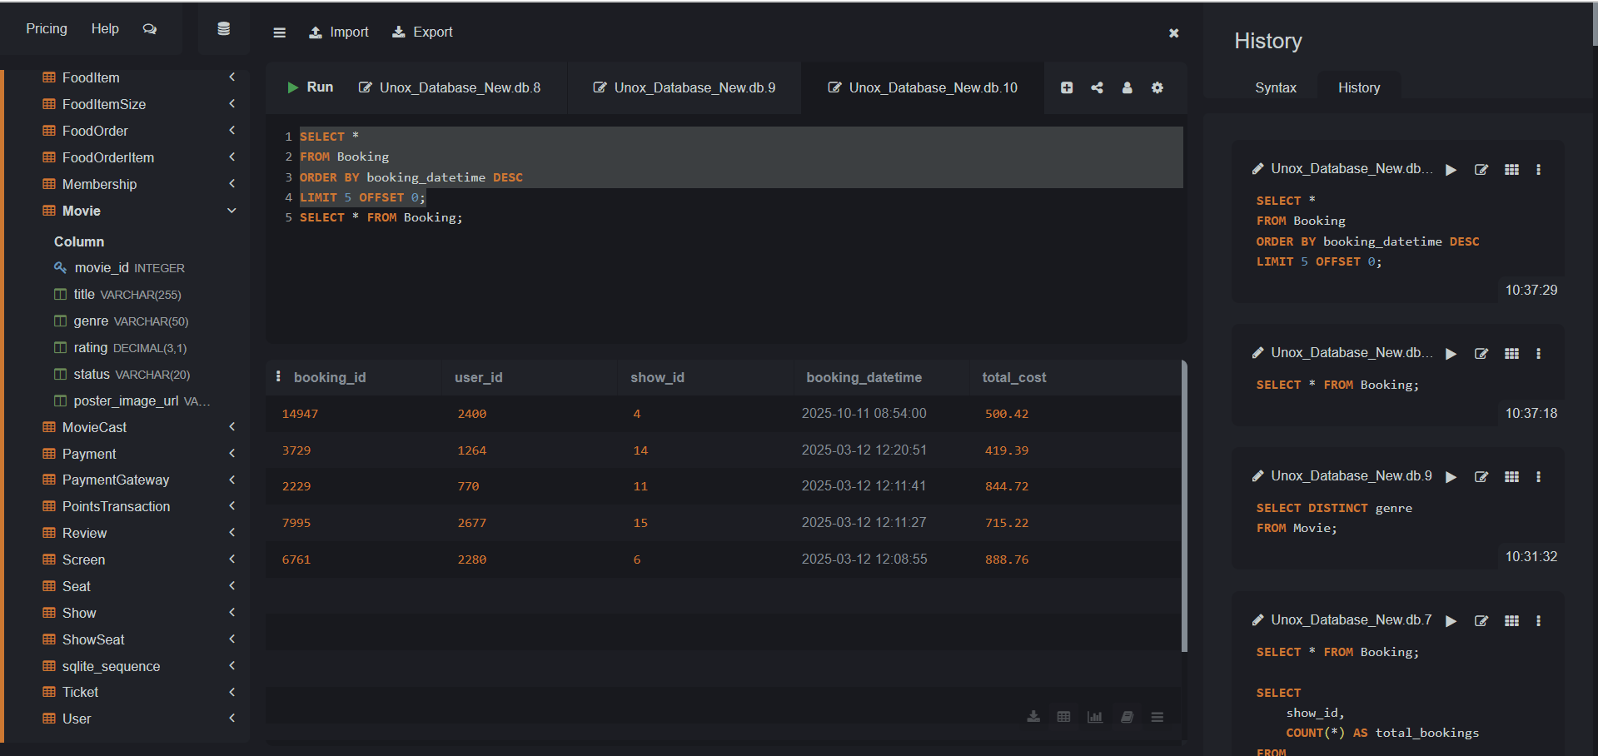
11. Calculate Revenue per Booking
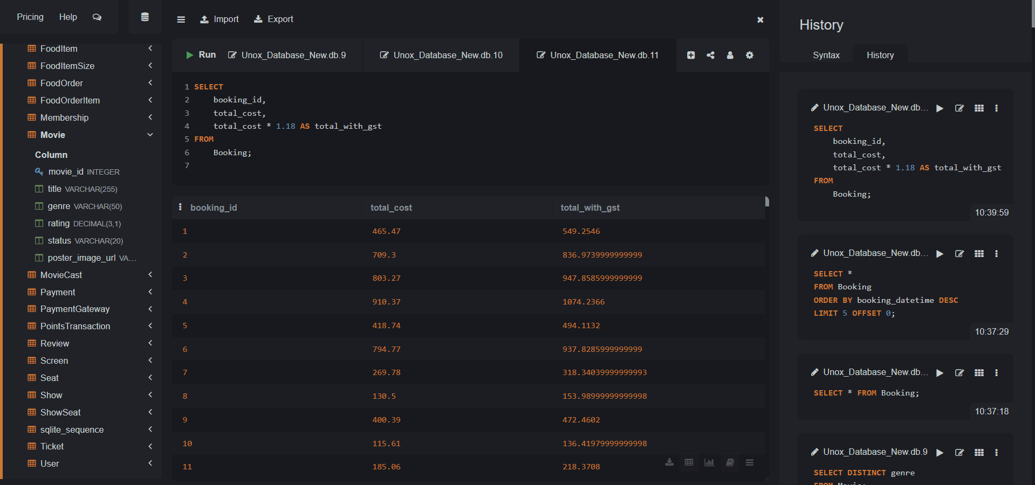
12. Categorize Movies by Rating
